formatted

Coral Reef Restoration Finance: Scaling Impact Through Outcome-Based Financing and Standardized Data 2
Abstract 2
1 Introduction 2
2. Case Studies on Coral Financing 3
2.1 Coral Restoration Foundation: Traditional Philanthropy 3
2.2 Blue Abadi: Trust Fund Model 3
2.3 Global Fund for Coral Reefs: Blended Finance and Impact Investment 4
2.4 Seychelles Blue Bond (Sovereign Debt Instrument) 4
2.5 Blue Natural Capital Financing Facility (Revenue-based Enterprise Incubation) 4
2.6 Pacific Ocean Finance Program (Insurance Mechanism) 4
2.7 Restoration Landscape Evaluation 5
3. Current Restoration Barriers 5
3.1 Restoration Costs 5
3.2 Ecological Complexity 6
3.3 MRV Unit Economics 6
3.4 Overhead Costs 7
3.5 ROI Challenges from Unpredictable Survival Rates 7
3.6 Reef Restoration’s Convoluted Relationship with Carbon 7
3.7 Ethical Considerations 8
3.8 Barriers Discussion 9
4. Outcome Based Financing Proposal 10
4.1 Sector Level Repayments 10
4.2 Outcome Based Financing Performance Thresholds 11
4.3 Calcium Carbonate Growth as Proposed Performance Metric 12
4.4 Alternative Performance Metrics 12
4.4.1 Fish Biodiversity 12
4.4.2 Coral Recruitment 13
4.4.3 Summary Assessment 13
4.5 Padangbai as a Case Study 14
4.6 Model Visualization 15
4.6.1 Baseline Scenario 15
4.6.2 Downside Scenario Example 15
4.6.3 Upside Scenario Example 16
4.6.4 Relevant Model Assumptions 16
5. Unlocked Potential for Future Carbon Market Integration 16
5.1 Data Collection as a Future Funding Catalyst 18
6. Conclusion 18
6.1 Future Research Directions 19
Works Cited 20

Coral Reef Restoration Finance: Scaling Impact Through Outcome-Based Financing and Standardized Data

Abstract
Coral reef restoration finance faces persistent barriers in aligning large-scale funding with ecological effectiveness and sustainable outcomes. This paper explores the potential of outcome-based financing (OBF) models centered on standardized, easily verifiable indicators like calcium carbonate growth as a practical basis for triggering performance-linked payments. By reviewing ecological, economic, and governance literature, as well as recent applied case studies from Padangbai and comparable geographies, the analysis demonstrates how OBF can reliably scale restoration by matching local economic co-benefits to transparent performance thresholds. The paper further examines the role of mandatory, portfolio-level data standardization in attracting blended and institutional capital. Key findings indicate that well-designed OBF frameworks not only catalyze local participation through fair risk-sharing, but also lay the groundwork for future access to premium blue carbon and markets that would enable additional scaling. Finally, the discussion highlights the need for future research on multiplier calibration and the social dynamics of stakeholder payments to ensure that a market- driven approach will deliver lasting ecological and economic returns.

1 Introduction
Coral reefs, lungs of the ocean and pillars of coastal communities, possess undeniable ecological and economic value. Yet, 50% of reefs have died since 1950, and those that remain are degrading at a rate of 7-8% per year. The scientific community has reached a consensus on the catastrophic ecological consequences of reef degradation, but the economic impact is less straightforward (Smithsonian). Monetary valuations of global reefs range across values like $9.9 trillion per year in ecosystem services and $150 billion per year in direct measurable economic value (WEF; Coral Vita). These estimates vary so immensely due to differences in their objectives, metric weights, discount rates, ecological scope, and co-benefit considerations. Within the wide range, there is little to no global or sectoral agreement about how to accurately account for reefs’ value to humanity or to the planet. If such a number does exist, our financial systems are not currently capable of generating it in a simple, defensible way. Regardless of what that value is, though, it is clear that current investment levels are not enough to prevent irreversible damage to ecosystems and economies.
The most universally cited and recognized global goal associated with blue carbon broadly is UN’s Sustainable Development Goal 14, Life Under Water. The measure, created in 2015, is intended to strengthen marine ecosystems and coastal communities through protection and responsible resource usage, a scope which includes coral reefs. Despite its stated ambitions, the SDG received investment levels below USD 10 billion across 2015-2019, compared to the $174.5 billion of yearly investment that it is estimated to need to accomplish the goal by 2030 (Johansen et al). These funding levels make it the least funded of the UN's SDG’s (O'Connor).
One contributing factor to underfunding is the misalignment between conservation- and market-oriented estimates. For example, Coral Vita, a prominent Bahamas-based social enterprise for large scale reef recovery, estimates that reefs generate over $150 billion in annual economic value worldwide, with projected losses of $55-75 billion per year by 2050 (Teicher). They also report that every dollar invested in reef conservation can return $5-15 in economic benefits through tourism, fisheries, and coastal protection. This frame of thinking suggests that coral restoration has an extremely obvious net-positive impact; not only does it avert loss, but it also promotes economic prosperity. Meanwhile, Future Data Stats, a leading market research firm, estimates the global Coral Restoration Market size to be $200 million with a CAGR of 15% (Future Data Stats). At this rate, the market would reach a size of $500 million by 2032. Here, even with a high growth estimate, the market valuation pales in comparison to the absolute value of Coral Vita’s economic loss estimate. Under the presumption that the conservation-oriented estimates are closer to ecological reality than the market ones, the scale of discrepancy between the two indicates that our market mechanisms are insufficient to meaningfully value ecological assets.
Amidst an aggregate-level failure to adequately fund the SDG or reefs, some nations are diverting money towards the cause through innovative blended financing deals.

2. Case Studies on Coral Financing
Historically, environmental financing has relied largely on government budget allocations and philanthropic contributions, neither of which are large enough to move the ecological needle on coral reef health. As such, several climate, governance, and financial institutions have developed new mechanisms to correlate ecosystem health with revenue generating outcomes or metrics. The following five case studies examine approaches to financing ocean conservation efforts, ranging from traditional funds to innovative methods.

2.1 Coral Restoration Foundation: Traditional Philanthropy
Established in 2007 in Florida, CRF invests primarily through philanthropy, grants, and donations to develop coral nurseries and restore reef ecosystems. Its financing model relies on charitable contributions from individuals, foundations, and government grants, with funds directed toward large-scale coral cultivation, outplanting, and community education, focusing on ecological and social benefits rather than financial returns (CRF).

2.2 Blue Abadi: Trust Fund Model
The Blue Abadi Fund, launched in 2017, is a marine conservation trust supporting Indonesia's Bird's Head Seascape, a highly biodiverse 36,000 km² network of Marine Protected Areas. Partners include Conservation International, The Nature Conservancy, WWF Indonesia, and the West Papua government. It combines a sinking fund for initial 3-5 years of operations with an endowment generating perpetual investment returns for ongoing efforts like enforcement, monitoring, and education. Capitalized at $23 million toward a $38 million target from philanthropy and grants, it integrates international funding with local management (Blue Abadi Fund).

2.3 Global Fund for Coral Reefs: Blended Finance and Impact Investment
The Global Fund for Coral Reefs (GFCR), launched in 2020 and managed by the UNDP Multi-Partner Trust Fund Office, channels blended finance to coral conservation in 20+ developing countries. The Green Climate Fund acts as anchor investor alongside philanthropies and development banks, with catalytic grants ($125M total) unlocking $375M in private capital through separate grant and equity windows for grassroots projects. Returns flow to reef-positive businesses in sustainable fisheries, blue carbon, and ecotourism, while impacts get tracked via standardized digital tools over 10 years (UNDP).

2.4 Seychelles Blue Bond (Sovereign Debt Instrument)
The Seychelles Blue Bond, issued in 2018 as a $15 million sovereign debt instrument, features a 10-year maturity with repayments structured in three installments starting 2026 (SDG Knowledge Hub). Managed between SeyCCAT's $3 million outcome-based grant fund and a $12 million Blue Investment Fund issuing low-interest loans to fishery businesses, it integrates outcome- and activity-based financing. The bond includes partial credit guarantees from the World Bank and concessional loans from the Global Environment Facility, which reduce risk and borrowing costs, attracting institutional investors such as Calvert Impact Capital. This structure delivers financial returns through bond repayments while financing marine conservation and fisheries.

2.5 Blue Natural Capital Financing Facility (Revenue-based Enterprise Incubation)
The Blue Natural Capital Financing Facility (BNCFF), established by IUCN with Luxembourg funding, has deployed €4+ million in grants since 2018 across 21 projects in 12 countries, mobilizing €17+ million in follow-on private investment for blue carbon, ecotourism, sustainable fisheries, and aquaculture. Like a startup incubator, it offers seed funding and technical assistance to create revenue from carbon credits, tourism fees, and fishery production, protecting 2.6 million hectares and strengthening 56 marine protected areas while enabling investor repayment through scalable ecosystem services (BNCFF).

2.6 Pacific Ocean Finance Program (Insurance Mechanism)
The Pacific Ocean Finance Program's parametric insurance mechanism features innovative climate and ecological risk transfer solutions where payouts are triggered automatically by environmental parameters such as cyclone intensity or sea surface temperature anomalies (Pacific Ocean Finance Program). Insurance claims are purchased mainly by Pacific Island governments or regional agencies seeking to protect blue infrastructure like coral reefs and mangroves from climatic shocks. When triggered, payouts flow directly to these governments or community-managed funds to rapidly finance disaster response, reef restoration, and livelihood support for vulnerable coastal populations. This approach, underpinned by regional risk pooling for affordability and scalability, provides immediate liquidity after events and incentivizes resilience while transferring risks efficiently to the insurance capital markets. The program partners include the Pacific Islands Forum Fisheries Agency, the Office of the Pacific Ocean Commissioner, World Bank, and Willis Towers Watson.

2.7 Restoration Landscape Evaluation
While the evolution from CRF’s traditional philanthropy to the blended finance architectures of the GFCR and Seychelles Blue Bond demonstrates a rapidly maturing capital stack, the aggregate landscape remains fragmented and functionally incapable of scaling to meet the estimated $1.5 trillion global resilience gap. These case studies reveal a "pilot-rich, system-poor" paradigm: while the BNCFF and GFCR successfully incubate revenue-generating models and the Pacific Ocean Finance Program introduces critical risk liquidity, these innovations operate in distinct silos that prevent cross-functional scaling. To move beyond isolated success stories like Blue Abadi’s endowment or localized sovereign debt instruments, the next generation of financial mechanisms must retain the rigorous impact monitoring and risk-pooling innovations of these pioneers but integrate them into a unified, interoperable framework that values ecosystem integrity as a primary asset rather than a byproduct of commercial activity.

3. Current Restoration Barriers

3.1 Restoration Costs
The cost of coral restoration varies widely, ranging from $6,000 to $143 million per hectare depending on technique and location. However, based on regional estimates for the Coral Triangle, a critical biodiversity hotspot, restoration costs average $250,000 per hectare. Given that up to 70% of the Coral Triangle’s 7.8 million hectares are at risk, full restoration would then require ~$1.37 trillion in capital expenditure, with an additional $136–$227 billion for perpetual monitoring (see Appendix A for detailed cost modeling).
These figures are orders of magnitude higher than the $200 million global restoration market. Even if the market grew 75-fold to $15 billion annually, it would cover less than 1% of the capital needed to restore just the at-risk portion of the Coral Triangle. This stark viability gap once again highlights the need for an alternative funding structure.

3.2 Ecological Complexity
The barriers to scaled coral restoration lie partially in the ecological mysteries surrounding reefs. Compared to keystone species in terrestrial ecosystems, coral reef behavior is significantly less predictable due to its complexity and diversity. A singular "coral" consists of hundreds of thousands of individual animals called polyps that perform cellular respiration using the photosynthetic outputs of zooxanthellae, single-celled symbiotic algae organisms that live in reefs. When the reef becomes physically stressed due to factors like changes in water conditions or fishing, the polyps expel their zooxanthellae, preventing them from obtaining nutrients and causing bleaching. This expulsion most often results from unfavorable thermal conditions that damage zooxanthellae. Such conditions in the water can be exacerbated by heatwaves, natural disasters, fishing activity, but even without these, the baseline trend is that waters are warming. Even when a replanting initiative is executed successfully and safe from disaster, reef survival is subject to several fluctuating factors that affect both polyp and zooxanthellae health.
The algae-polyp relationship has ignited a new field of research on understanding coral reefs' heat resistance levels in order to improve genomic strategy when replanting, considering that such a large percentage of global reefs exist in warming waters. For example, Stanford Professor Palumbi has developed a low-cost method for testing corals' heat resistance, identifying mass deaths during bleaching events as a core detriment to restoration and accessibility of materials as a requirement for scalable replanting technology (Palumbi et al.). Such innovations could make crucial tailwinds in de-risking coral restoration, both ecologically and economically, but are not yet widespread.

3.3 MRV Unit Economics
One of the other significant financial barriers to coral restoration scale-up is the high cost of Monitoring, Reporting, and Verification (MRV). Effective MRV is essential for validating restoration success and quantifying carbon sequestration but typically demands substantial ongoing costs. Recent industry estimates place average annual MRV expenses at roughly $1,273 per hectare, translating into a present value of $24,860 to $41,433 per hectare when discounted at 3–5% rates for perpetuity (Morfo). These costs reflect the need for continuous ecological monitoring, remote sensing, data analysis, and reporting to funders and carbon credit buyers. For coral restoration specifically, MRV involves tracking coral cover, survivorship, growth rates, and genetic diversity to validate ecological success, often using labor-intensive methods such as diver surveys and photo-mosaics. Increasingly, it also includes verifying co-benefits like coastal protection or fisheries enhancement, requiring precise baseline data and continuous monitoring to meet the rigorous standards of funders and emerging biodiversity markets (ICRI).
In the voluntary carbon market context, such MRV costs vastly outstrip the carbon revenue potential of coral restoration when measured solely by current carbon prices, which average around $4.80 to $7 per tonne (CarbonCredits). Coral MRV complexity exceeds terrestrial projects because of coral's ecological and spatial heterogeneity (Schopmeyer et al.). The mismatch between MRV costs and carbon credit income inhibits access to the carbon market, eliminating a common avenue for sustained private sector investment.

3.4 Overhead Costs
Critically, 20–40% of total restoration project costs are program management, administration, and planning overhead, not direct planting activity (Frontier Marine Science). Labor cost variation by geography explains the global gap. Diver labor in Kenya costs $6.33/hour versus $70.43/hour in the US, a 10× multiplier (Ocean Revive). Additionally, ocean-based nurseries are substantially cheaper than land-based systems. In Kenya, ocean-based nurseries cost as little as $0.0004–$0.059 per coral per day compared to $0.003–$0.116 per coral per day in the US, representing up to an 18× cost difference depending on cleaning protocols. However, direct transplantation of coral fragments bypasses nursery costs entirely, with outplanting-only costs at $10.63 per coral in Philippines tourism-led programs (Frontier Marine Science) versus total per-coral costs of $57.36 when including capital and overhead. With such different regional cost structures, every individual project requires a unique initial capital contribution.

3.5 ROI Challenges from Unpredictable Survival Rates
Coral restoration costs vary dramatically depending on technique, local context, and scale, with conventional methods ranging from around USD $6,000 for nursery-based gardening to as much as USD $4 million per hectare for substrate addition and complex interventions. Most projects operate at small scales and are of limited duration, with a median project length of just 1–2 years (Bayraktarov et al.). Median reported survival rates for restored corals range from about 61% to 70%, but these figures typically reflect only short-term monitoring windows. When advanced techniques or higher volume projects are considered, costs can be substantially higher.
While early survival rates for coral restoration range from 55% and 70% in the first year, data is heavily skewed by short-term monitoring and does not account for long-term ecological outcomes. Many meta-analyses highlight that 60% of projects report less than 18 months of monitoring (Bayraktarov et al.). Long-term success is far more uncertain and highly sensitive to unpredictable environmental stressors such as extreme heat, bleaching events, storms, disease, and predation, which can drive rapid and near-total losses, especially in young or newly outplanted colonies (JRC EU; Miami Waterkeeper). Compared to other forms of environmental investment like forest conservation or wetland restoration, which have longer asset lifespans and lower risk of wipeout, coral restoration carries greater short-term ecological risk and longer investment horizons. De-risking and risk-sharing, therefore, are essential to improve investment.

3.6 Reef Restoration’s Convoluted Relationship with Carbon
The disparity between the rate of ecological degradation and the rate of restorative intervention is not merely a funding problem; it is a structural one. Organized systems that successfully bridge this gap, such as the global reforestation sector, share a distinct characteristic: they have commoditized impact through standardized, non-negotiable metrics. In the forestry sector, the emergence of the Voluntary Carbon Market (VCM) has successfully transformed tree planting from a philanthropic activity into a tradeable asset class. The impact of this shift is visible in the comparative data between the pre- and post-market expansion periods. In 2020, global forest finance was largely stagnant at approximately $12 billion annually, with the vast majority dependent on public sector budgets.
By 2025, alongside sustained corporate net-zero commitments, annual forest finance had nearly doubled to $23.5 billion from $12 billion in 2020 (CarbonCredits). Critically, the composition of this funding shifted: the share of private capital investment in forests grew from 25% in 2020 to 40% in 2025, directly validating the premise that standardized metrics attract institutional scale that philanthropy cannot match (UNEP). Forests absorb 7.6 billion tons of CO₂ annually (one-fifth of global emissions), but they receive less than 2% of climate finance (CarbonCredits). Even within this underfunded category, though, the VCM was able to substantially scale reforestation finance. Coral restoration, by comparison, lacks this organized architecture. Without a standardized metric to serve as a proxy for value, coral restoration cannot access the blended finance structures or outcome-based pricing signals that have allowed forest finance to double in just five years.
While a standardized metric is essential for financial scaling, the ecological justification for such investment must be rigorously scrutinized. Scientifically, coral reefs interact with the carbon cycle differently than forests. While trees actively sequester carbon in their biomass as they grow, the process of coral calcification (building the calcium carbonate skeleton) initially releases CO₂ into the water column through changes in ocean chemistry (Nature Communications). However, healthy coral reefs are the critical physical barrier that protects "Blue Carbon" assets, mangroves and seagrass beds, which sequester carbon at rates up to 10 times higher than tropical forests (Guerra). Without the wave-breaking structure of the reef, these carbon-rich coastal ecosystems erode, releasing millennia of stored carbon back into the atmosphere. Therefore, the "carbon value" of a restored reef lies not just in its own growth, but in its function as the shield for the ocean's most effective carbon sinks. Additionally, over geological timescales, the burial of coral rubble and carbonate sediment does act as a permanent sink, but this is a process measured in centuries rather than fiscal quarters.

3.7 Ethical Considerations
The argument for restoring reefs, even when 85% of global cover is degraded, rests on the principle of "functional integrity" rather than total historical recovery. Just as a small patch of 10 trees in a deforested landscape cannot function as a forest, a sparse reef with low coral cover suffers from the "Allee effect," where colonies are too distant to successfully reproduce sexually (Mumby). Research confirms that fertilization success drops to nearly zero when colonies are separated by more than 15 to 20 meters PNAS. This means a surviving but fragmented natural reef is effectively "reproductively dead." Active restoration that plants dense clusters of coral creates a functional "reproductive engine" that can re-seed surrounding areas, breaking the cycle of decline Frontiers in Marine Science. Thus, even a small, restored patch has an exponentially higher ecological ROI than a large, sparse degraded area because it restores the biological mechanism of self-renewal. From an ethical perspective, these restored patches serve as "genetic arks," preserving the library of biodiversity, 25% of all marine life, needed to repopulate the ocean when global conditions eventually stabilize.

3.8 Barriers Discussion
The convergence of these barriers creates a systemic market failure. Current funding models are structurally incapable of absorbing the high overhead of site-specific management or the biological risks of early-stage outplanting, leaving the sector dependent on fragmented philanthropy that cannot scale. To break this paralysis, the restoration market requires a mechanism that decouples upfront risk from long-term value.
One of the central roadblocks of climate mitigation financing is that restorative action does not often generate an immediate, tangible economic gain correlated with the averted economic loss. Rather, the economic gain is realized at a macroscopic scale over a long time horizon, by many stakeholders. For example, by 2050, the tourism sector is expected to lose $15-20 billion, the fisheries sector $3-4 billion, coastal protection $32-41 billion in additional damage, ecosystem services $2-3 billion, and pharmaceuticals $5-7 billion in unrealized potential (Coral Vita). These losses are significant but difficult to conceptualize for any individual player. None of the losses can be absolutely guaranteed to directly hit any individual stakeholder, and the benefits of any one stakeholder's contribution to preventing that loss would be shared by all stakeholders, creating a free rider problem.
Instead of centering the goal around projected aggregate losses, an alternative approach would be to measure and communicate current economic reliance on reefs. For example, LivingSeas, a Bali-based marine conservation organization, conducted a study on their Padangbai restoration site, finding that it generates at least $277,164 per year for the local economy just from recreational value (money that coral-planting guests spend on accommodation, food, transport, and ecotourism) (LivingSeas). Without the Padangbai restoration activities, businesses in these sectors would suffer a substantial immediate hit, in addition to the broader anticipated damage from reef degradation. Incorporating such valuations into stakeholder communication is a crucial element of incentivizing contribution.
In order to mobilize capital from these sectors, they need to believe that they will individually realize a benefit from their contribution. Crucially, this requires that the restorative efforts they contribute to are localized and successful. Any ambiguity about whether the newly planted/restored coral will survive (and hence benefit them) exacerbates their reluctance to contribute. Therefore, contribution must hinge on successful, not intended restoration.

4. Outcome Based Financing Proposal
Under the proposed financing model, an impact investor provides upfront capital to cover the variable costs of restoration at an established site, expecting a modest, positive return aligned with impact investment standards rather than high-risk market rates. The financial structure begins with a localized negotiation where community stakeholders, tourism operators, and public sector representatives agree on an appropriate rate of return for the investor, reflecting both the value they place on the reef's sustenance and the need to incentivize capital flow. Crucially, repayment is contingent on success: these stakeholders commit to repaying the principal plus the agreed return only if the restoration meets specific ecological milestones. Success is measured solely by calcium carbonate (CaCO₃) accretion, a singular proxy chosen for its straightforward quantification of reef growth and its potential to generate data for future carbon market integration. This arrangement shifts the risk to the investor while ensuring that payments from stakeholders function as a sustainment fee for the ecosystem services they currently rely on, rather than for theoretical future losses. Over time, the aggregation of these site-specific agreements balancing practitioner cost estimates, investor return expectations, and stakeholder willingness to pay creates a transparent, market-driven valuation of coral ecosystems.
To operationalize this model, a localized "Reef Trust" or Special Purpose Vehicle would act as the intermediary to aggregate diverse stakeholders, ranging from dive shops to municipal governments, and manage the conditional repayment contracts. This structure differs fundamentally from traditional grants or sovereign bonds by shifting performance risk entirely to the investor, as stakeholders face no upfront costs and incur financial liability only when verified calcium carbonate accretion confirms ecological success. For stakeholders, participation is incentivized by this "no-cure, no-pay" guarantee, allowing them to secure essential ecosystem services without risking capital on failed interventions. To ensure fiscal predictability, stakeholder payments are strictly capped at the principal plus the pre-negotiated return, preventing cost overruns even if restoration exceeds biological expectations. This design creates a precise, bounded financial instrument that aligns the incentives of capital providers with the ecological and economic beneficiaries of a healthy reef.

4.1 Sector Level Repayments
Determining sector-specific repayment percentages begins with a calculation of each sector's share of total economic benefit derived from restoration or reef-dependent activities. At Padangbai, this involved tracking how much money restoration-program visitors spend within each sector (accommodation, food, transport, etc) and calculating each sector's proportional revenue. This creates a baseline quantification of current reliance. Stakeholder contributors are not limited to the local economy. National governments, international tourism operators, and multinational seafood distributors all rely on healthy reefs and face economic losses from reef degradation, even if their operations span multiple countries or regions. These non-local stakeholders can participate in repayment and contribute a percentage of total obligations based on their economic dependence on reef health or their potential losses if restoration does not succeed. Each sector is then informed of two figures: the percentage of total project repayment they are allocated based on this calculation, and the estimated loss they would face under continued reef degradation if restoration did not proceed.
Critically, this sector contribution and cost-based funding approach does not require arriving at a comprehensive or perfectly accurate valuation of all ecosystem services provided by coral reefs. Rather, current economic reliance serves as a pragmatic proxy for the value each sector derives from reef health, avoiding the significant methodological challenges that have historically complicated ecological valuation and financing. Expected loss under different degradation scenarios is communicated as a contextualizing figure, presented as a range reflecting ecological uncertainty. For example, if accommodation represents 28% of current visitor spending, accommodation providers are allocated 28% of the total repayment obligation and are shown scenario-based estimates of their potential revenue loss over the project period under pessimistic, moderate, and optimistic reef decline trajectories. These ranges acknowledge that future reef loss is uncertain, but they ground stakeholder contributions in demonstrable current economic dependence rather than attempting to capture all co-benefits or achieve a singular "correct" valuation of reef worth. By anchoring the model to observable, current economic relationships rather than comprehensive ecosystem service accounting, the framework remains transparent and defensible while avoiding the valuation bottleneck that has limited scaling of restoration finance.

4.2 Outcome Based Financing Performance Thresholds
In order to design scalable outcome-based financing models, performance thresholds must be clearly defined and measurable with low barriers. Currently, standard coral restoration success criteria include colony-level metrics such as growth and survival, with 65% of monitoring studies focusing on these indicators; a smaller proportion (35%) combine them with additional ecological factors like recruitment, competition, and predation (NOAA). Beyond these, the scientific community has urged for an even broader group of metrics including coral reproduction, genetic diversity, recruitment of associated reef organisms, and improvement of overall reef habitat such as structural complexity, shelter, and carbonate production to evaluate program performance and adaptive management outcomes (Frontier Marine Science).
While all of these metrics would yield invaluable insights about restoration, they are resource-intensive to collect, and when they are required to qualify for funding, they exclude whole swaths of restoration practitioners, effectively inhibiting restoration volume. With this in mind, practitioners and funders alike would benefit from a singular metric or simple set of metrics to communicate and prove their success.

4.3 Calcium Carbonate Growth as Proposed Performance Metric
Coral restoration has immense co-benefits, but they are difficult to measure in a standardized manner because they rely on so many assumptions and other changing variables. Due to this complexity, an outcome-based model with scalable potential requires low barriers to collecting accurate, standardized performance data. Calcium carbonate growth is one such performance indicator. Divers conducting routine reef surveys can measure reef surface growth with little to no special equipment. At LivingSeas, scientific researchers measured coral growth during the same time period via recurring weight-based monitoring, photo documentation, and a nursery mapping survey (Kautt). Out of these methods, they found that the weighing method was low-cost and field-adaptable, but it results in only general trends with some data inconsistencies. However, they noted that in a study of a longer duration, the ultimate aggregate data trends will likely exceed the margin of error caused by day to day measurement variability from environmental noise, boat movement, and unstable platforms. The feasibility of using simple weight measurements as a reliable success metric is still unknown, but if it does ultimately yield results consistent with strategies like satellite imaging and thorough surveys, then it unlocks greater simplicity for creating performance-based securities and for a wider array of practitioners to be eligible to receive that capital.
In addition to its financial and logistic viability, calcium carbonate production is also an ideal metric because of its relationship with carbon sequestration, a popular environmental metric. Calcium carbonate growth encapsulates net reef metabolism: healthy, growing reefs accrete carbonate at positive rates (e.g., Padangbai at 5.14–9.00 kg/m²/year), whereas degraded reefs experience net erosion and carbonate loss. Unlike metrics varying by diver skill, site conditions, and monitoring duration, calcium carbonate growth provides an objective metric enabling portfolio-level comparison and aggregation. In fact, publications in Nature Communications (2019) and recent systematic reviews (2025) establish calcium carbonate as a robust, quantifiable proxy for both reef health and carbon sequestration (Nature Communications).

4.4 Alternative Performance Metrics
Beyond calcium carbonate (CaCO₃) growth, two of the most prominent alternative metrics for assessing coral restoration success are fish biodiversity and coral recruitment rates.

4.4.1 Fish Biodiversity
Fish biodiversity as a metric for restoration success is typically measured through a combination of methods, including diver-based underwater visual censuses, video transects, and, more recently, environmental DNA (eDNA) sampling from water samples. During standard visual surveys, trained divers swim along predefined transects or belt lines and record the presence, abundance, and sometimes the behavior or size classes of fish species within fixed areas. Fish biodiversity is tied to coral health both directly and indirectly. Directly, healthy, structurally complex coral reefs provide habitat, shelter, and resources necessary for supporting a diverse array of fish species. Many reef fish are obligate coral dwellers and cannot persist if live coral cover or three-dimensional structure is lost. Indirectly, changes in coral cover and complexity cause shifts in fish community composition, with declines in coral specialist species and overall richness following loss, and gradual return of those groups when healthy coral is restored. Thus, fish biodiversity is a strong yet not perfectly linear indicator: while robust fish communities suggest healthy corals, some transient increases in fish diversity may occur due to habitat generalists or algal grazers after disturbance, and methodological limitations (observer bias, sampling window, cryptic species) can influence results. For this reason, many monitoring protocols encourage combining fish biodiversity with direct coral and habitat complexity assessments for a full picture of reef restoration outcomes.

4.4.2 Coral Recruitment
Coral recruitment refers to the process by which new coral larvae settle, survive, and gradually grow into juvenile colonies, typically defined as those ranging from 1 to 5 cm in diameter. This metric tracks not just the initial settlement of coral spat, but also their survival past critical early-life bottlenecks. Successful recruitment is therefore a strong signal of a reef system that is naturally replenishing itself, with new cohorts overcoming competition, predation, and environmental stress to join the population. In restoration, tracking recruitment enables practitioners to assess whether interventions (like outplanting, substrate improvement, or larval supplementation) are leading to sustainable increases in coral population and genetic diversity (NOAA). This differs from metrics like calcium carbonate growth, which measure only the physical expansion of reef structure (i.e., the mass of skeleton produced), not the underlying biological dynamics of population replacement or recovery. While CaCO₃ growth captures how much three-dimensional habitat is created, recruitment directly reflects the ability of the reef to recover and persist through repeated disturbance, as new corals colonize available space, replace dying adults, and drive long-term recovery. Monitoring recruitment provides insight into the ecological success and future sustainability of restoration: without high rates of new recruit survival and transition to reproductive maturity, restored reef structure alone does not guarantee a sustainable coral ecosystem. However, recruitment requires specialized equipment and labor, once again limiting eligible practitioners.

4.4.3 Summary Assessment
Calcium carbonate (CaCO₃) growth remains a strong candidate for the central performance metric in outcome-based coral restoration funding due to its direct link to reef structure and ecosystem services. This metric is reliable, scalable, and cost-effective, allowing standardized measurement of the physical substrate that supports fish, invertebrates, and protects coastlines. Its practicality lies in the ability to quantify accretion with consistent protocols, and it is directly tied to restoration inputs and ecological function (NOAA). Unlike more variable biological indicators, CaCO₃ growth offers straightforward comparability across sites and years.
While alternatives such as fish biodiversity and coral recruitment offer nuanced insights into ecological success, each brings significant challenges. Fish communities respond to both natural and restoration-driven changes with indirect lags, subject to observer variation and external influences. Coral recruitment rates fluctuate seasonally and spatially, are less readily quantified, and require intensive monitoring to standardize. Ultimately, while a suite of metrics would provide the richest picture of restoration outcomes, real-world funding models require methods that are simple, cost-efficient, and broadly comparable. Calcium carbonate growth meets these criteria most reliably; it proxies core reef functions and can be measured objectively across projects and regions, making it this model’s preferred standardized metric for linking finance to performance. Notably, though, this model can work with any simple proxy metric, so as MRV technology or funding priorities evolve, the model remains functional.

4.5 Padangbai as a Case Study
At Padangbai, outcome-based financing can be applied to scale restoration using concrete economic data. According to the LivingSeas report, guests spending on restoration activities generates approximately $277,164 annually in total economic benefit to Padangbai, distributed across four sectors: restoration activity ($2,740/month), accommodation ($1,630.05/month), food ($862.67/month), and transport ($594.91/month) (LivingSeas).
Using a three-year scaling scenario with 1,200 Mars Reef Stars at $65 per star, initial capital requirement is $78,000. Stakeholders determine sector contributions based on their proportional share of existing reef-dependent revenue. Accommodation represents 31% of total spending, food 16%, transport 11%, and restoration activity 5%. The remaining 37% comes from additional contributors including fisheries, the municipal government, and regional tourism operators dependent on reef health.
With conservative survival projections (50% in Year 1, 70% in Year 2, 80% in Year 3) and age-based CaCO₃ accretion (3 kg in first year of life, 6 kg in second year, 7 kg in third year), total CaCO₃ production across all cohorts accumulates. Year 1 produces 150 kg from the first cohort; Year 2 produces 660 kg (150 kg from the cohort's second year plus 510 kg from the newly deployed cohort); Year 3 produces 1,276 kg across three age classes. If the funder requires a 5% annual return, the repayment target is $78,000 × (1.05)^3 = $90,305, yielding a payout rate of $25.25/kg based on expected cumulative production of 2,086 kg over three years.
Year 1 repayment is 150 kg × $25.25 = $3,788; Year 2 is 660 kg × $25.25 = $16,665; Year 3 is 1,276 kg × $25.25 = $32,219. Each year, sectors contribute their proportional share. If survival or accretion exceeds projections—for instance, if Year 2 produces 700 kg instead of 660 kg—that year's repayment increases proportionally, accelerating investor recovery. If environmental stress reduces survival, repayments scale down, extending timelines. This ensures stakeholders pay only for actual outcomes while maintaining incentives for rigorous field management.

4.6 Model Visualization
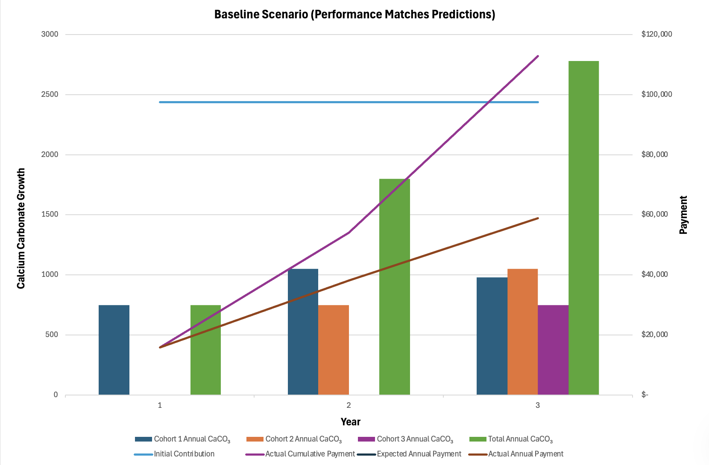 | 4.6.1 Baseline Scenario  Figure X shows the baseline scenario, where the reef performs exactly as predicted. The bars on the left axis track annual calcium carbonate growth from three cohorts, with total CaCO₃ rising as older cohorts mature. The lines on the right axis show the planned annual payment, the realized annual payment, and the resulting cumulative repayment, which in this case overlap closely and exceed the initial 97,500‑dollar contribution by year three.
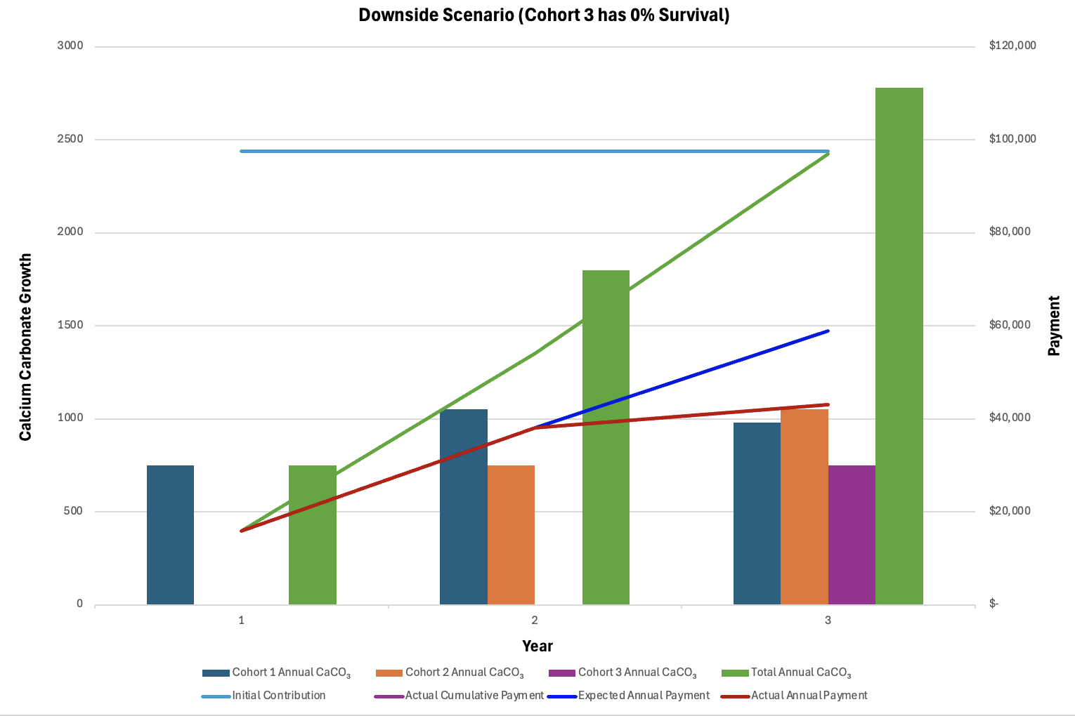 | 4.6.2 Downside Scenario Example  This scenario illustrates a downside case where the third cohort experiences 0 percent survival, so it adds no new calcium carbonate in year three. Total CaCO₃ growth and actual annual payments both flatten relative to the planned payment path, and cumulative repayments only barely exceed the initial $97,500 contribution by the end of the period. The model is still functional due to its already conservative survival estimates.
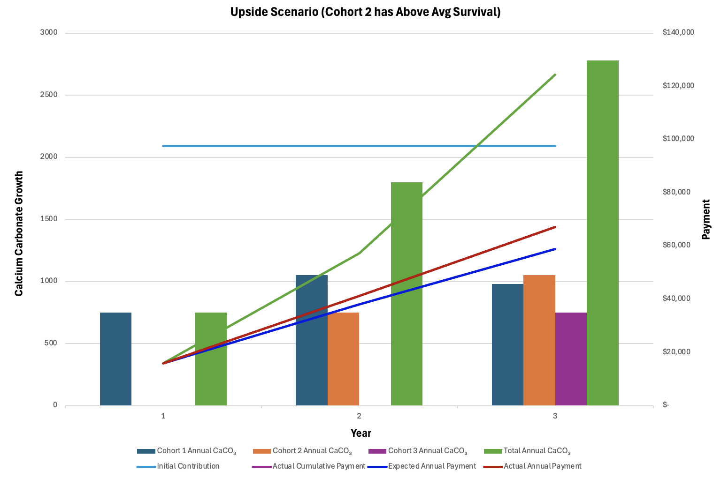 | 4.6.3 Upside Scenario Example  This upside scenario models a case where the second cohort achieves 10% higher survival and accretion than expected in years 2 and 3, boosting total annual calcium carbonate growth relative to the baseline. As a result, the red line for actual annual payments rises above the blue expected‑payment path, and the purple cumulative‑payment line reaches the investor’s repayment target earlier and with a larger surplus by year three.
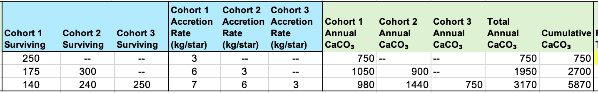  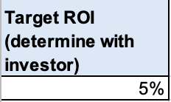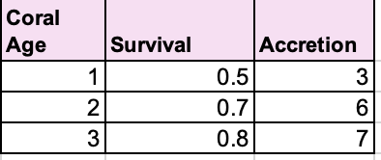 | 4.6.4 Relevant Model Assumptions  For these scenarios, expected survival and accretion rates were estimated based on empirical averages, and target ROI was estimated based on traditional impact investment goals. Each specific site using this model to expand would input their accurate historical survival rates and species-specific accretion patterns.

5. Unlocked Potential for Future Carbon Market Integration
After several years of sustained collection of verified calcium carbonate growth data across multiple coral restoration sites, financial institutions can create a cumulative data repository with profound implications for future financial market expansion. This data infrastructure enables coral restoration to transition from outcome-based financing (OBF) dependent on demonstrated local economic benefits into a broader "blue carbon" asset class comparable to mangrove and seagrass restoration markets that are already operational within voluntary carbon markets.
Blue carbon (carbon sequestered in coastal and marine ecosystems) has emerged as a distinct asset class within voluntary carbon markets. Mangrove forests and salt marshes sequester carbon at rates 10 times greater than tropical forests, and seagrass meadows, comprising only 0.1% of the ocean floor, store 10-18% of all organic carbon buried in the ocean (Seagrass Carbon). Blue carbon project methodologies are now established under major carbon registries, including the Verra VM0033 Methodology and BlueCAM in Australia. Due to the immeasurable value of the co-benefits associated with blue carbon sequestration, mangrove carbon credits already trade at premium prices compared to generic forest or land-use credits (S&P Global). The voluntary market explicitly recognizes that coastal ecosystem restoration generates multiple, stackable value streams beyond carbon alone. However, coral restoration has historically been excluded from such markets. One reason is additionality ambiguity, referring to the uncertainty about whether new coral growth would have occurred without restorative intervention, especially with sparse levels of baseline data. Additionally, coral reefs are subject to quick wipeouts from bleaching events and storm mortality, so they are not as permanent of an ecological asset as mangrove forests or seagrass beds. Finally, because they are omitted from standardized markets, practitioners do not have standardized data sets, creating a chicken/egg problem where there are no agreed upon metrics because there is no system to collect them for, but there can't be a system without a set of agreed upon metrics.
However, if multiple coral restoration sites across geographies adopt standardized calcium carbonate measurement protocols verified by independent third parties, the aggregate dataset provides additionality evidence, insights on permanence vs risk (enabling additional insurance integration), and standardized measurement protocols, improving future prospects of joining carbon registries or adopting mangrove frameworks.
Verra's SD VISta Nature Framework (launched October 2024) creates a parallel mechanism to traditional carbon credits: "Nature Credits" representing "one tonne of net biodiversity outcomes, measured in quality hectares (Qha)" (Verra). This framework explicitly acknowledges that nature restoration generates multiple outcome streams (biodiversity, carbon, livelihoods) that should be credited separately, not forced into binary carbon-only metrics. A coral restoration project could issue both "Coral Carbon Credits" (based on calcium carbonate sequestration) and "Nature Credits" (based on biodiversity recovery, fisheries benefit, coastal protection), allowing buyers to purchase specific outcome bundles matching their portfolio objectives. Plan Vivo Nature Certificates similarly enable bundling of carbon credits with verified co-benefits (Plan Vivo). Such a model with supporting data could eventually position coral restoration as a composite security and commanding premium pricing in institutional markets.
If a standardized coral carbon methodology emerges and achieves registry approval (Verra, Plan Vivo, or American Carbon Registry), coral restoration projects could access a voluntary carbon market projected to grow from $2 billion (2023) to $7–35 billion by 2030 (MSCI). Blue carbon projects, currently representing ~3–5% of VCM volumes, are projected to expand 5–10x as methodologies standardize and institutional buyers recognize coastal ecosystems as critical.
Amidst turmoil in the broader carbon credit market, these premium credits would be well-positioned alongside other well-verified, high-integrity credits that continue to attract stable demand in a market otherwise plagued by overvaluation and sharp declines for lower-quality offsets. Credits lacking robust baseline methodologies or third-party verification have faced significant drops in price and trust, increasingly leading buyers to concentrate on products with rigorous documentation and multiple co-benefits (Orbify). According to BCG, up to 87% of carbon credits issued in past years carry a high risk of failing to deliver real or additional climate benefits (BCG), further depressing average market prices and catalyzing a shift toward niche, resilient asset classes anchored in transparency and scientific rigor. As a result, a standardized, independently verified coral methodology would likely occupy the same resilient, niche segment as today's blue carbon credits from mangrove and seagrass projects, which command some of the market's highest prices thanks to proven integrity and co-benefit value.

5.1 Data Collection as a Future Funding Catalyst
The sustained collection of standardized calcium carbonate data by all practitioners is not just a technical requirement; it serves as critical infrastructure for unlocking capital and driving higher returns through competition and efficiency, even if carbon market integration does not materialize. This principle is well-demonstrated by the cross-sector results of BCG's ESG Data Convergence Initiative (EDCI), which found that standardizing sustainability metrics across over 9,000 portfolio companies improved comparative benchmarking and operational optimization, resulting in a 4–7% increase in realized profitability (BCG). Importantly, the EDCI reveals that externally-imposed data requirements, especially when tied to capital access, can rapidly transform standardization from optional to essential.
For coral restoration, standardized data collection enables portfolio-level actors to compare projects, allocate resources efficiently, and replicate high-performing approaches. Individual practitioners, while generating meaningful local economic value, typically see little direct short-term benefit from joining these standardized networks. The collective benefits emerge only at scale. This creates a public goods dilemma: standardized data is valuable to the group but not obviously to individuals, so strong leadership and contractual requirements are needed to align incentives. By embedding data mandates into outcome-based financing contracts and linking annual funding to the delivery of calcium carbonate data collected with simple, robust protocols, funders can ensure adoption. While standardization is not costly (measuring calcium carbonate is simple and inexpensive), its success depends on governance, including clear requirements, verification, and centralized repositories for data sharing and learning. BCG's EDCI experience shows that such approaches are entirely feasible: with sustained leadership and credible performance incentives, a field can build the standardized benchmarks and data quality that attract far greater capital flow and learning than would ever occur from isolated, one-off projects.

6. Conclusion
This paper has illustrated that the quest for scalable, impactful coral reef restoration is fundamentally a financial, organizational, and measurement challenge as much as it is an ecological one. Traditional funding paradigms like philanthropy, trust funds, and even innovative blended finance facilities have yet to match the unprecedented economic threat facing global reefs, often failing to ensure long-term sustainability, robust outcome measurement, or portfolio-wide efficiency. The proposed outcome-based financing (OBF) model, anchored by simple and standardized calcium carbonate growth metrics, creates a viable bridge between global capital and local, measurable ecosystem recovery. By rooting payments in clearly quantified ecological performance and aligning those payments with the realized economic benefits for local stakeholders, OBF minimizes free-rider problems, aligns incentives, and makes restoration participation attractive to both practitioners and investors. The Padangbai case study illustrates how an OBF security can more than double restoration area and local economic returns within five years, while remaining affordable for direct beneficiaries. Critically, this approach also builds the data infrastructure needed for future participation in emerging blue carbon and "nature credit" markets—an essential path for evolving coral restoration into a widely investable, self-reinforcing asset class. Ultimately, the central insight is that portfolio-level data standardization, coupled with institutional leadership and persistent capital access incentives, unlocks returns not otherwise achievable by siloed or fragmented efforts.

6.1 Future Research Directions
Future research should empirically test and optimize the pricing of multipliers linking simple physical metrics like calcium carbonate growth to local economic benefit, across a diversity of geographies and economic dependency levels. Studies should evaluate the operational performance of OBF models in a range of local and regional contexts, identifying optimal incentive structures for both practitioners and stakeholders. Further, high-priority work remains in validating the long-term reliability and comparability of field-based calcium carbonate measurements against advanced monitoring technologies (e.g., satellite, photogrammetry) to solidify confidence in standard protocols. Additional research is needed on the governance frameworks that most effectively mandate or incentivize standardization—balancing practitioner flexibility with investor information needs. As blue carbon methodologies for coral ecosystems mature, interdisciplinary studies should examine credit permanence, additionality, and stacking with co-benefit (e.g., nature credit) frameworks. Finally, social science research is required to understand stakeholder willingness to pay for long-diffuse benefits and to model the feedback loops between restoration outcomes, insurance contracts, and public/private finance. These areas of inquiry will be critical in maturing coral restoration finance into a robust, efficient marketplace that drives systemic ecological recovery.

Works Cited
Bayraktarov, E., et al. "Coral Restoration – A Systematic Review of Current Methods, Efficacy and Emerging Technologies." PLOS ONE, vol. 15, no. 1, 2020, https://journals.plos.org/plosone/article?id=10.1371%2Fjournal.pone.0226631.
"Blue Abadi Fund." Blue Abadi Fund, 2025, blueabadifund.org/en/. Accessed 19 Dec. 2025.
Boston Consulting Group. ESG Data Convergence Initiative Insights. 2025.
Boston Consulting Group. "Carbon Credits Market Report." BCG, 2024,
https://www.climateimpact.com/case-studies/BostonConsultingGroup/.
Blue Natural Capital Financing Facility. About BNCFF. IUCN, https://www.bluenaturalcapital.org.
CarbonCredits.com. "Live Carbon Prices Today." CarbonCredits.com, 2025,
https://carboncredits.com/carbon-prices-today/.
“Forest Finance Hits Record Growth in 2025: Investment Doubles for Nature-Based Climate Action.” CarbonCredits.com, 16 Oct. 2025,
https://carboncredits.com/forest-finance-hits-record-growth-in-2025-investment-doubles-for-nature-based-climate-action/.
Climate Policy Initiative. "Annual Climate Finance Doubled between 2018 and 2022 but Needs Much More." Climate Policy Initiative, 4 Nov. 2024,
https://www.climatepolicyinitiative.org/press-release/global-landscape-of-climate-finance-2024/.
Conservation International. Blue Abadi Fund: GEF Project Documentation. Global Environment Facility, 2017.
Coral Digest. "Economic Valuation of Reefs." Coral Digest, 31 July 2020,
https://www.coraldigest.org/management/economicvaluation/index.html.
"CRF Florida." Coral Restoration Foundation, 2 Feb. 2025, coralrestoration.org/where-we-work/crf-florida/. Accessed 19 Dec. 2025.​

Teicher, Samuel. " The Economic Impact of Coral Reef Loss: A Comprehensive Analysis. " Coral Vita, 2 Oct. 2025, coralvita.co/coral-cafe/economic-impact-of-coral-reef-loss/. Accessed 19 Dec. 2025.
Florida's Coral Reef. "Value." Florida's Coral Reef, 17 Feb. 2022,
https://floridascoralreef.org/topics/value.
Frontier Marine Science. "Early-Stage Outcomes and Cost-Effectiveness of Implementing Coral Restoration." Frontiers in Marine Science, vol. 11, 2024,
https://www.frontiersin.org/journals/marine-science/articles/10.3389/fmars.2024.1418784/full.
Future Data Stats. “Coral Restoration Market Size & Industry Growth 2030.” Future Data Stats, 2024, www.futuredatastats.com/coral-restoration-market. Accessed 19 Dec. 2025.​
Global Fund for Coral Reefs. "GFCR: Driving Ocean Resilience Through Blended Finance." United Nations Development Programme, 28 Jan. 2021,
https://www.undp.org/press-releases/global-fund-coral-reefs-launches-fundraising-campaign.
Guerra-Vargas, L., et al. "Stronger Together: Do Coral Reefs Enhance Seagrass Meadows 'Blue Carbon' Potential?" Frontiers in Marine Science, vol. 7, 28 July 2020, www.frontiersin.org/journals/marine-science/articles/10.3389/fmars.2020.00628/full. Accessed 19 Dec. 2025.​
Gupta, Ankit, and Shashank Sisodia. "Voluntary Carbon Credit Market Size, Growth Outlook 2025-2034." GMI Insights, February 2025,
https://www.gminsights.com/industry-analysis/voluntary-carbon-credit-market.
International Coral Reef Initiative. "Launch of the Coral Reef Breakthrough." ICRI, 2 Oct. 2023, https://icriforum.org/coral-breakthrough/.
IUCN. Blue Natural Capital Financing Facility.
https://www.bluenaturalcapital.org.
Joint Research Centre, European Commission. Coral Restoration Long-Term Monitoring and Environmental Stressors. 2023.
Kautt, Lilly. Quantifying Coral Reef Restoration Impact: Internship Report. Living Seas, 2025, d11n7da8rpqbjy.cloudfront.net/livingseas/460808263995Quantifying_Coral_Reef_Restoration_Impact__Internship_Report_Lilly_Kautt.pdf. Accessed 19 Dec. 2025.
Livingseas Foundation. Impact Report June 2024. Livingseas Foundation, June 2024, d11n7da8rpqbjy.cloudfront.net/livingseas/371874394275Impact_Report_June_24_Livingseas.pdf. Accessed 19 Dec. 2025.
Miami Waterkeeper and University of Miami. "Coral Diseases and Water Quality Play a Key Role for Coral Restoration and Survival Efforts." University of Miami News, 9 Aug. 2025,
https://news.miami.edu/rosenstiel/stories/2025/03/coral-diseases-and-water-quality-play-a-key-role-for-coral-restoration-and-survival-efforts.html.
Morfo. MRV Costs for Coral Restoration Projects. 2024.
Mumby, Peter J., et al. "Allee Effects Limit Coral Fertilization Success." Proceedings of the National Academy of Sciences, vol. 121, no. 52, 23 Dec. 2024, https://doi.org/10.1073/pnas.2411831121. Accessed 19 Dec. 2025.
MSCI. Voluntary Carbon Market Projections. 2023.
National Oceanic and Atmospheric Administration. "Coral Reef Monitoring Methods and Ecosystem Economics." NOAA, https://www.noaa.gov/.
National Oceanic and Atmospheric Administration. Comparing Coral Colony Surveys From In-Water Observations and Analysis. 21 May 2021,
https://repository.library.noaa.gov/view/noaa/32873/noaa_32873_DS1.pdf.
Nature Communications. "Role of Carbonate Burial in Blue Carbon Budgets." Nature Communications, vol. 10, 2019,
https://digitalcommons.usf.edu/fac_publications/3783/.
Ocean Revive. "Diver Labor Costs and Coral Nursery Economics." Ocean Revive, 2025.
O’Connor, Jack. “Focus on the Least Funded SDG: Lessons from the UN Ocean Conference Ahead of the High-Level Political Forum.” UNU-EHS Commentary, United Nations University, 10 July 2025, https://unu.edu/ehs/commentary/focus-least-funded-sdg-lessons-un-ocean-conference-ahead-high-level-political-forum.
Orbify. "The Complex Path to Trustworthy Carbon Credits: Insights from Elias Ayrey of Renoster." Orbify, 8 Sept. 2025,
https://orbify.com/blog/the-complex-path-to-trustworthy-carbon-credits-insights-from-elias-ayrey-of-renoster.
"Pacific Ocean Finance Programme – Insurance (POFPI)." Ocean & Climate Platform, 13 Dec. 2021, ocean-climate.org/en/pacific-ocean-finance-programme-insurance-pofpi/. Accessed 19 Dec. 2025.
https://unsouthsouth.org/2022/11/14/launch-of-pacific-regions-first-ever-parametric-insurance-scheme/.
Palumbi, S. R., et al. "Using Naturally Occurring Climate Resilient Corals to Construct Heat-Tolerant Reef Communities." Proceedings of the National Academy of Sciences, vol. 116, no. 20, 2019,
https://www.pnas.org/doi/10.1073/pnas.1721415116.
Plan Vivo. Nature Certificates for Biodiversity and Carbon Bundling. Nature Finance, 2023.
Reef Resilience Network. "Value of Reefs." Reef Resilience, 31 Dec. 2024,
https://reefresilience.org/value-of-reefs/.
"Restoration Activities." International Coral Reef Initiative, 14 Dec. 2023, icriforum.org/restoration-activities/. Accessed 19 Dec. 2025.
S&P Global Commodity Insights. "'Blue Carbon' Gains Interest in Effort against Greenhouse Gases, but Challenges Remain." S&P Global, 25 Oct. 2021,
https://www.spglobal.com/commodity-insights/en/news-research/latest-news/energy-transition/102521-blue-carbon-gains-interest-in-effort-against-greenhouse-gases-but-challenges-remain.
Schopmeyer, S., et al. "Coral Reef Restoration Ecological Complexity and MRV Requirements." Journal of Marine Research, 2024.
SDG Knowledge Hub. "Seychelles Launches First Blue Bond." SDG Knowledge Hub, 5 Nov. 2018,
https://sdg.iisd.org/news/seychelles-launches-first-blue-bond/.
Seagrass Restoration. "Seagrass Restoration Enhances 'Blue Carbon' Sequestration in Coastal Sediments." PMC, vol. 4, no. 8, 2013,
https://pmc.ncbi.nlm.nih.gov/articles/PMC3743776/.
Smithsonian Institution. Coral Reefs at Risk: 50% Decline Since 1950. Smithsonian Magazine.
United Nations Environment Programme. State of Finance for Forests 2025: Unlock. Unleash. United Nations Environment Programme, Oct. 2025, www.unep.org/resources/report/state-finance-forests-2025.[2]
Johansen, Despina “The cost of saving our ocean - estimating the funding gap of sustainable development goal 14” Science Direct Marine Policy, Feb. 2020, https://www.sciencedirect.com/science/article/abs/pii/S0308597X19305111
Verra. SD VISta Nature Framework v1.0. Verra, Oct. 2024,
https://www.verra.org.
World Economic Forum. "Why Coral Reefs Are Such a Decisive Climate Investment." World Economic Forum, 2 June 2025,
https://www.weforum.org/stories/2025/01/coral-reefs-ultimate-climate-investment/.

appendix
Add: link to excel model

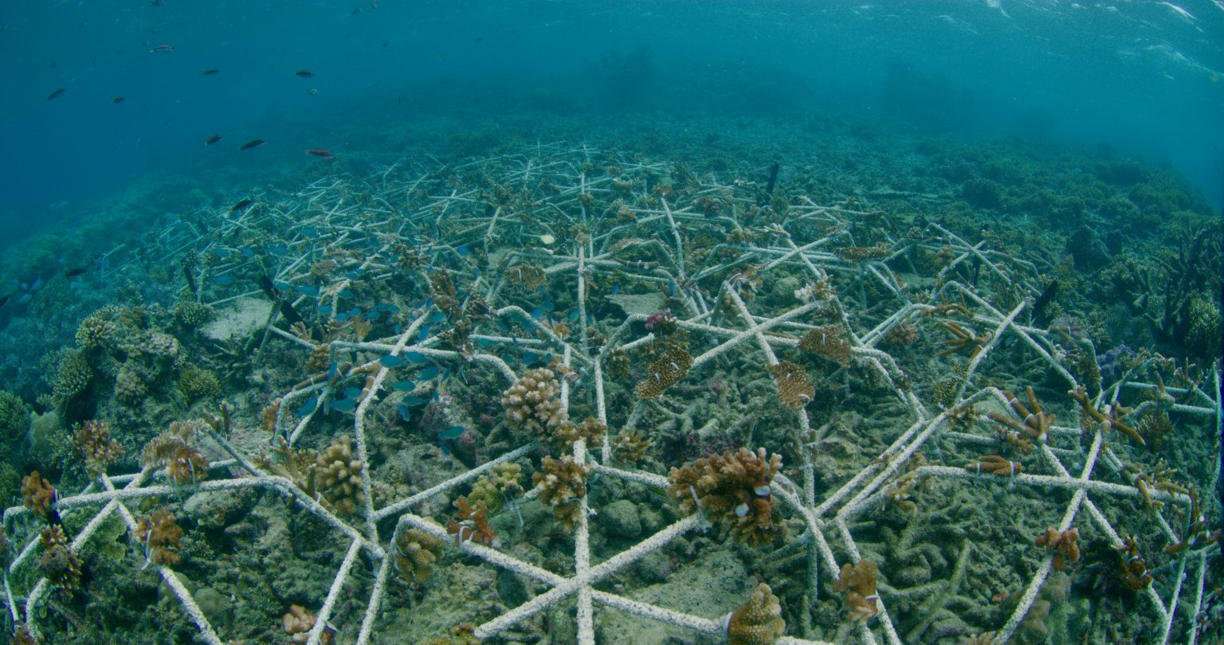
Mars Star

Appendix A: Coral Triangle Restoration Cost Modeling")
Assumptions & Calculation Methodology:
- Unit Cost: $25 per square meter ($250,000 per hectare) based on direct transplantation estimates for the Coral Triangle region [Marine Pollution Bulletin, 2019].
- At-Risk Area: The Coral Triangle contains 7,827,200 hectares of reef [World Resources Institute, 2012].
- Risk Factor: 70% of reefs are projected to be lost or degraded within 50 years [Reefs at Risk Revisited, 2011].
- Target Restoration Area: 5,479,000 hectares (70% of total area).
Capital Expenditure (CapEx):
- $250,000/ha * 5,479,000 ha = $1.37 trillion
Operational Expenditure (MRV):
- Annual Cost: $1,273 per hectare for monitoring, reporting, and verification [Morfo, 2024].​
- Perpetuity Calculation: $1,273 / 0.03 (3% discount rate) = $42,433 per hectare (Present Value).
- Total MRV Liability: $42,433/ha * 5,479,000 ha ≈ $232 billion (upper bound).
Total Estimated Liability:
- $1.37 trillion (CapEx) + $0.23 trillion (MRV PV) = $1.6 trillion
Note: This static model does not account for potential cost reductions via economies of scale or technological innovation in automated outplanting.

Disparity in Coral Reef Valuation
Value/Estimate | Scope/Details | Source
$9.9 trillion / year | Global ecosystem services (fisheries, tourism, coastal protection, etc) | WEF
$11 trillion/year | Ecosystem services (protection, tourism, fisheries) | Coral Digest
$150+ billion/year | Global direct economic impact (annual), multi-sector (tourism, fisheries, protection) | Coral Vita
$375 billion/year | Total goods & services from reefs worldwide | Reef Resilience
$35 billion/year | Annual global coral reef tourism | Florida's Coral Reef

